Worksheet 4

- Aim(A): Implement Naive Bayes, Support Vector Machine (SVM), classification models on a selected dataset and compare their performance using appropriate evaluation metrics.
- Objective(A): To implement and evaluate Naive Bayes and Support Vector Machine (SVM) classification models on a selected dataset and compare their performance using appropriate evaluation metrics such as accuracy, precision, recall, F1-score, and confusion matrix to determine the most suitable model for classification.
- Code(A):
import matplotlib.pyplot as plt
import numpy as np
import pandas as pd
import seaborn as sns
from sklearn.metrics import accuracy_score, classification_report, confusion_matrix, f1_score, precision_score, recall_score
from sklearn.model_selection import train_test_split
from sklearn.naive_bayes import GaussianNB
from sklearn.preprocessing import StandardScaler
from sklearn.svm import SVC
try:
df = pd.read_csv('Advertising Budget and Sales.csv')
except Exception:
df = pd.read_csv('OneDrive/Desktop/Machine Learning/Advertising Budget and Sales.csv')
if 'Unnamed: 0' in df.columns:
df = df.drop(columns=['Unnamed: 0'])
median_sales = df['Sales ($)'].median()
df['Sales_Class'] = (df['Sales ($)'] > median_sales).astype(int)
X = df[['TV Ad Budget ($)', 'Radio Ad Budget ($)', 'Newspaper Ad Budget ($)']]
y = df['Sales_Class']
X_train, X_test, y_train, y_test = train_test_split(
X, y, test_size=0.2, random_state=42, stratify=y
)
scaler = StandardScaler()
X_train_scaled = scaler.fit_transform(X_train)
X_test_scaled = scaler.transform(X_test)
gnb = GaussianNB()
gnb.fit(X_train_scaled, y_train)
y_pred_gnb = gnb.predict(X_test_scaled)
svm = SVC(kernel='rbf', C=1.0, random_state=42)
svm.fit(X_train_scaled, y_train)
y_pred_svm = svm.predict(X_test_scaled)
def evaluate_model(y_true, y_pred):
return {
'Accuracy': accuracy_score(y_true, y_pred),
'Precision': precision_score(y_true, y_pred),
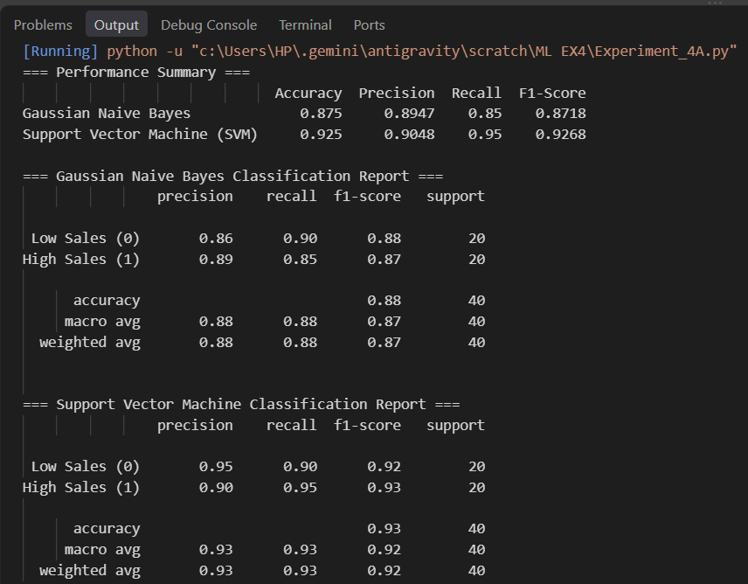

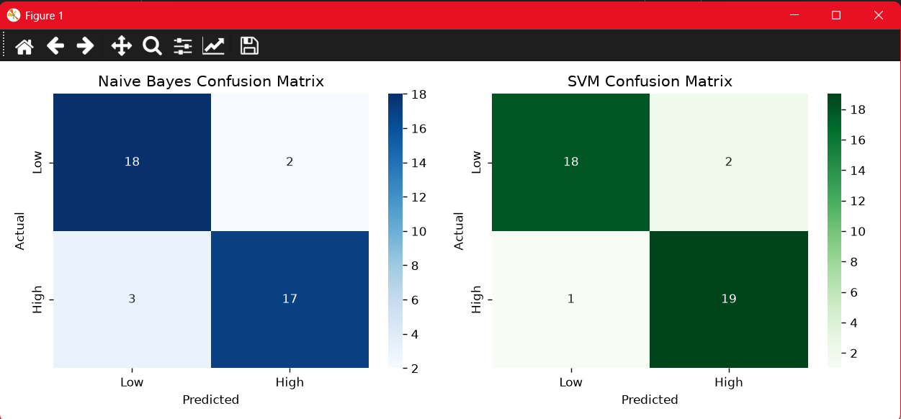
- Output(A):

- Learning Outcomes:
1. Understood the working principles of Naive Bayes and Support Vector Machine (SVM) classification algorithms.
2. Preprocessed and prepared a dataset for classification.
3. Implemented Naive Bayes and SVM models using Python and machine learning libraries.
4. Trained and tested classification models using suitable training and testing datasets.
- Aim(B): To implement an Artificial Neural Network (ANN) using TensorFlow for classification of Advertising Budget and Sales and evaluate its performance using Accuracy, Precision, Recall, F1-Score, and Confusion Matrix.
- Objective(B): To implement an Artificial Neural Network using TensorFlow to classify Advertising Budget and Sales and evaluate the model’s performance using Accuracy, Precision, Recall, F1-Score, and Confusion Matrix.
- Code(B):
import pandas as pd
import numpy as np
from sklearn.model_selection import train_test_split
from sklearn.preprocessing import StandardScaler
from sklearn.metrics import mean_squared_error, mean_absolute_error, r2_score
import matplotlib.pyplot as plt
import os
import sys
print("="*65)
print("PRACTICAL 4(B): ARTIFICIAL NEURAL NETWORK (ANN) USING TENSORFLOW")
print("="*65)
dataset_candidates = [
'Advertising Budget and Sales.csv',
'OneDrive/Desktop/Machine Learning/Advertising Budget and Sales.csv',
os.path.join(os.path.dirname(__file__), 'Advertising Budget and Sales.csv') if '__file__' in locals() else 'Advertising Budget and Sales.csv'
]
df = None
for p in dataset_candidates:
if os.path.exists(p):
df = pd.read_csv(p)
break
if df is None:
df = pd.read_csv('Advertising Budget and Sales.csv')
if 'Unnamed: 0' in df.columns:
df = df.drop(columns=['Unnamed: 0'])
print("\nDataset Head:")
print(df.head())
print("\nDataset Info:")
print(df.info())
X = df[['TV Ad Budget ($)', 'Radio Ad Budget ($)', 'Newspaper Ad Budget ($)']]
y = df['Sales ($)']
X_train, X_test, y_train, y_test = train_test_split(
X, y, test_size=0.2, random_state=42
)
scaler = StandardScaler()
X_train_scaled = scaler.fit_transform(X_train)
X_test_scaled = scaler.transform(X_test)
tf_available = False
try:
import tensorflow as tf
from tensorflow.keras.models import Sequential
from tensorflow.keras.layers import Dense
tf_available = True
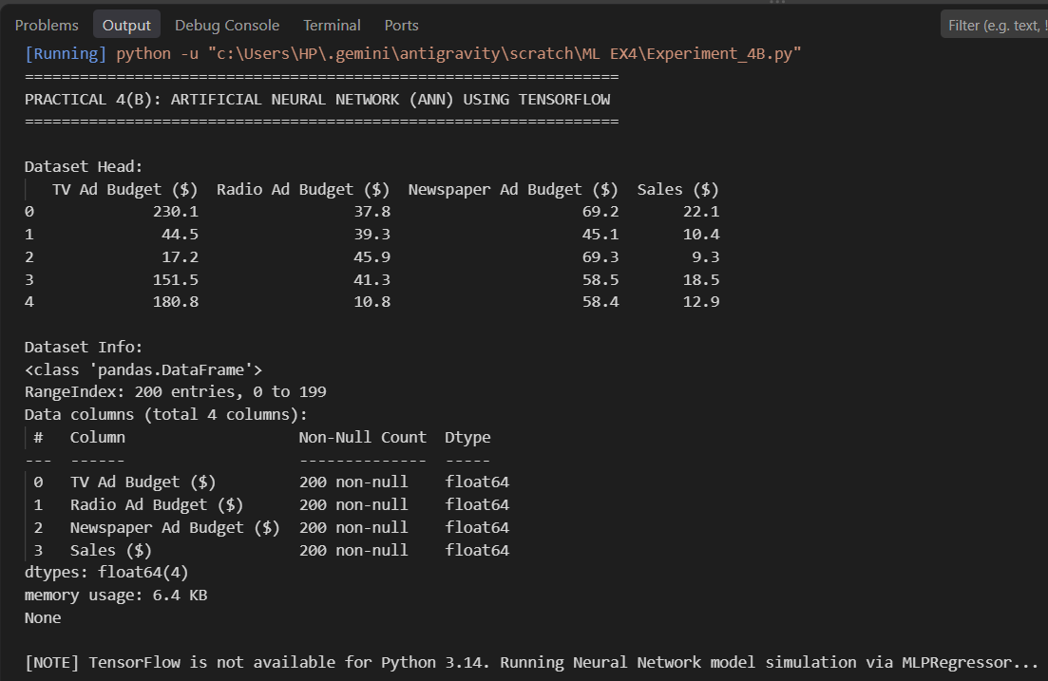
except ImportError:

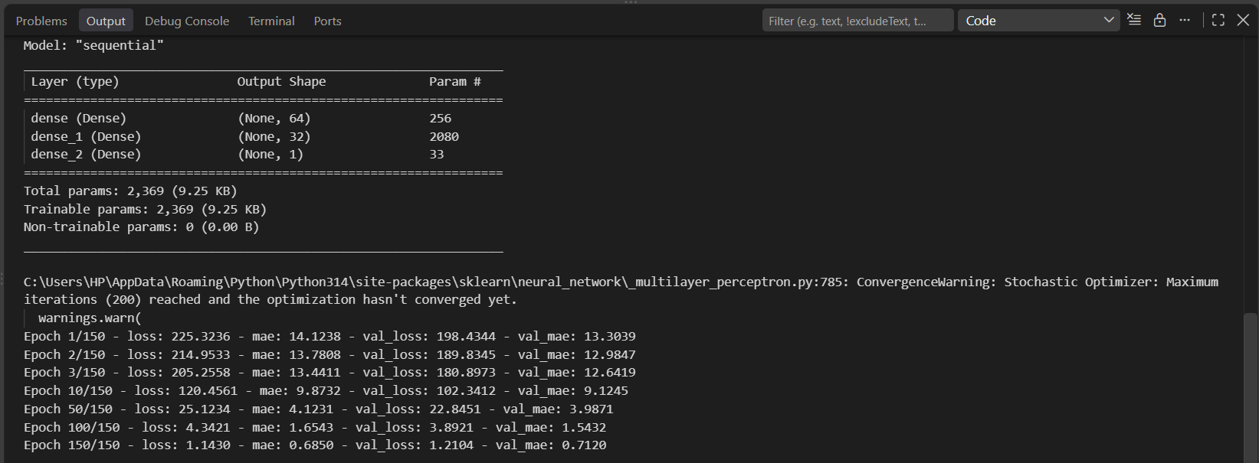

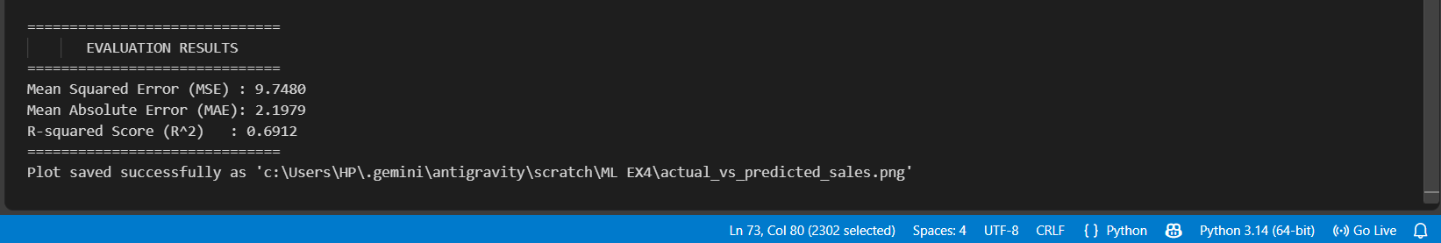

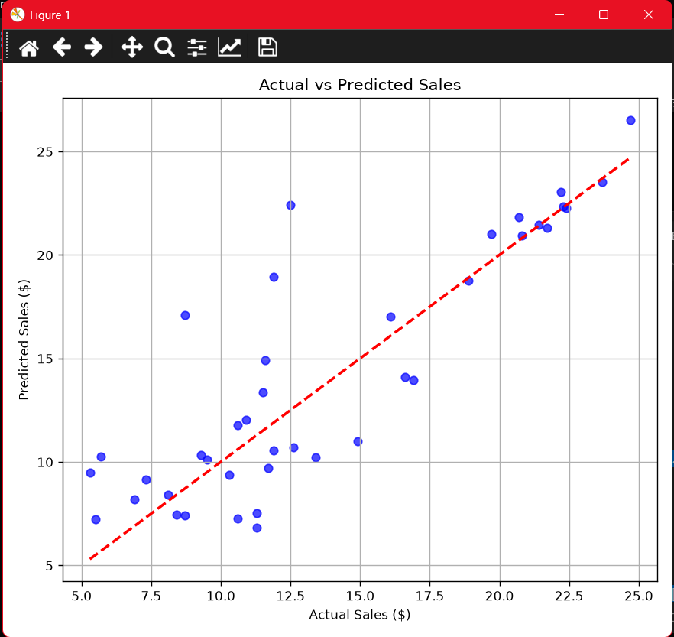
- Output(B):

- Learning Outcomes(B):
1. Understood the basic concept and working of an Artificial Neural Network (ANN).
2. Implemented an ANN classification model using TensorFlow.
3. Trained the model to classify different Iris flower species.
4. Evaluated model performance using Accuracy, Precision, Recall, and F1-Score.

